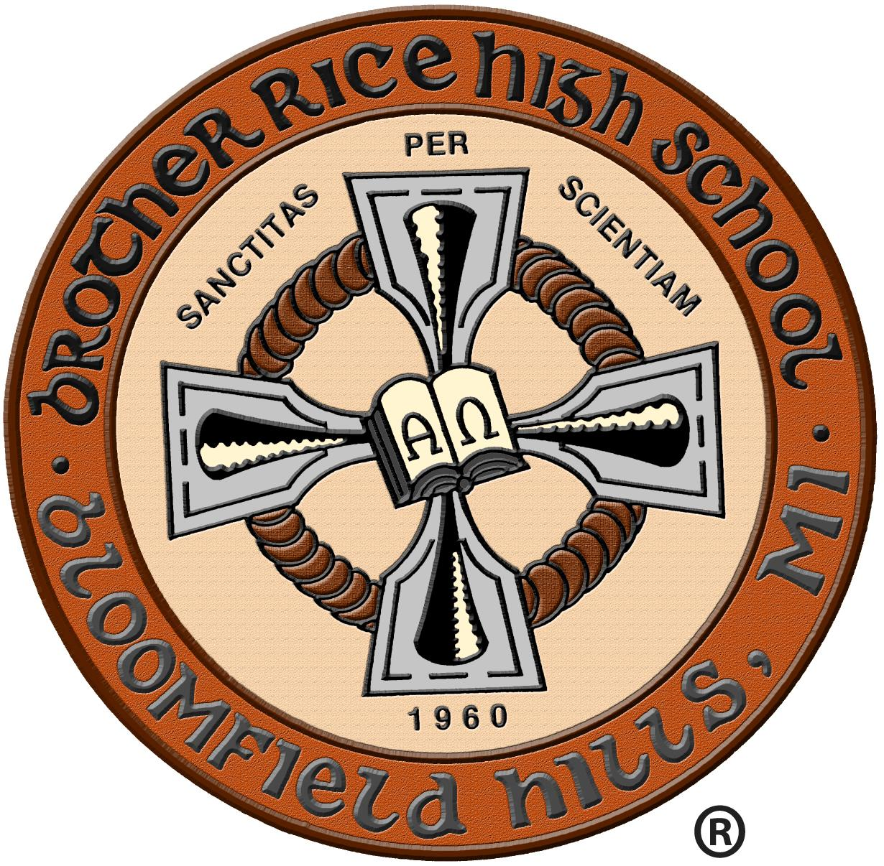

Brother Rice High School Partnership Scholarship

What is the Brother Rice Partnership Scholarship?
Brother Rice has developed a scholarship program which we believe strengthens our on-going relationship with the middle schools in the Archdiocese of Detroit. In an effort to live the Mission of Brother Edmund Rice, the Archdiocese of Detroit, and the Catholic Church, this scholarship rewards high quality Catholic school students for their commitment to spiritual and academic achievement. This scholarship is renewable each year, provided the student is in good academic standing and is a positive influence in the community, living the Essential Elements of Brother Rice.

How do students qualify for this award?
All applicants must:
- Complete all components and submit the Metro Detroit Catholic High School Freshman Application to Brother Rice High School.
- Take the November or December High School Placement Test and send scores to Brother Rice High School.
- Complete an interview with Brother Rice Admissions Director (offered during “Warrior for a Day” visit or via telephone/skype).
- Complete the Partnership Scholarship Application and essay and submit to Brother Rice High School.
- Must be an 8th grade student attending an Archdiocese of Detroit Catholic school.

What are the Essential Elements of an Edmund Rice Christian Brother Education?
- Evangelize youth within the Mission of the Church
- Proclaim and witness to Catholic Identity
- Stand in solidarity with those marginalized by poverty and injustice
- Foster and invigorate a Community of Faith
- Celebrate the value of dignity of each person and nurture the development of the whole person
- Collaborate and share the responsibility for the Mission
- Pursue excellence in all endeavors

Brother Rice High School was founded in 1960 by the Congregation of Christian Brothers of Ireland. Brother Rice is a private, fully accredited, four year Catholic College Preparatory School for young men. It is owned and operated by the Congregation of Christian Brothers- which was founded in 1802 by Br. Edmund Ignatius Rice, after whom the school is named. Today there are over two thousand Brothers in twenty five countries, teaching young people in 300 institutions around the world. In the spirit of Blessed Edmund Ignatius Rice, the school fosters the spiritual, intellectual, cultural, and moral development of its students. The Brother Rice community promotes excellence through an environment conducive to life-long personal growth, and responsible, moral decision making in a Christian atmosphere.

Please contact 248-833-2020 / admissions@brrice.edu with any questions.

Brother Rice High School Partnership Scholarship Application

Student Information:

Name:

Address:

City: State: Zip:

Phone: E-mail address:

Current School:

Essay Topic:
In 300 words or less explain how your grade school has prepared you to be a successful student at Brother Rice High School. Include topics of Faith, Academics, and Leadership.

Applicants may submit a portfolio of achievements (not required, but preferred):
  - Christian Values (involvement in church community)
  - Academics (honor or enrichment classes, NJHS, class president etc.)
  - Leadership Skills (programs that you have been involved with)
  - The desire to help others (Christian service)
  - School pride (involvement in extra-curriculars)

Return the scholarship application with the essay to Brother Rice High School:

Brother Rice High School
Attn: Admissions
7101 Lahser Rd.
Bloomfield Hills, MI 48301
admissions@brrice.edu
Fax: 248-833-2011

Please contact 248-833-2020 / admissions@brrice.edu with any questions.

